**Bahria University, Lahore Campus**

Department of Computer Science

Lab Journal 01

**(Spring 2024)**

|  |  |  |
| --- | --- | --- |
| Course: | **Compiler Construction – Lab** | Date: _28-02-2024____ |
| Course Code: | CSL 323 | Max Marks: 10 |
| Faculty’s Name: | Mr. M Mudassar |  |

Name: _AFFAN AHMAD _ Enroll No: 03-134221-003__ Class: _BS(cs)-5A__________

Objective(s):

Upon completion of this lab session, learners will be able to:

* The objective of this exercise is to get you to write, compile, and run several simple programs in C++ that make use of basic pointers and structures.

Lab Tasks:

Your lab report is expected to contain the following for each exercise:

* C++ Source Code (any file)
* Screenshot of your output (optional)

**Task 1:**

Consider any one of the struct of your own choice (optionally can be the Accounts, Pets, Vehicle, MobileShop, etc.). Structure must have at-least 4 variables (one int, char [], double, and string). The program must access struct variables, assign values to them, prints them, and them into a function to print the values.

**#include<iostream>**

**#include<string>**

**using namespace std;**

**struct mobileshop{**

**int productid;**

**char brand[50];**

**double price;**

**string modelname;**

**};**

**void mobiledetails(mobileshop& m1)**

**{**

**cout << "product id is :"<< m1.productid<< endl;**

**cout << "brand name is :"<< m1.brand<< endl;**

**cout << "price is :"<< m1.price<< endl;**

**cout << "model name is :"<< m1.modelname<< endl;**

**}**

**int main()**

**{**

**mobileshop m1={1,"apple",35000,"galaxy"};**

**cout << "product id is :"<< m1.productid<< endl;**

**cout << "brand name is :"<< m1.brand<< endl;**

**cout << "price is :"<< m1.price<< endl;**

**cout << "model name is :"<< m1.modelname<< endl;**

**cout << "mobile details is :"<< endl;**

**mobiledetails(m1);**

**return 0;**

**}**

**Output :**

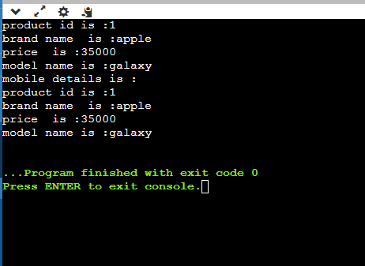

## Task 2:

Consider any one of the struct of your own choice (optionally can be the Accounts, Pets, Vehicle, MobileShop, etc.). Structure must have at-least 4 variables (one int, char [], double, and string). The program must access struct variables, assign values to them, prints them, and them into a function to print the values. Do this task using pointer variables.

#include<iostream>

#include<string>

using namespace std;

struct mobileshop{

int productid;

char brand[50];

double price;

string modelname;

};

void mobiledetails(mobileshop * m3)

{

cout << "product id is :"<< m3->productid<< endl;

cout << "brand name is :"<< m3->brand<< endl;

cout << "price is :"<< m3->price<< endl;

cout << "model name is :"<< m3->modelname<< endl;

}

int main()

{

mobileshop m1={1,"apple",35000,"galaxy"};

mobileshop *m2= &m1;

cout << "product id is :"<< m1.productid<< endl;

cout << "brand name is :"<< m1.brand<< endl;

cout << "price is :"<< m1.price<< endl;

cout << "model name is :"<< m1.modelname<< endl;

cout << "mobile details is :"<< endl;

mobiledetails(m2);

return 0;

}

**Lab Grading Sheet :**

|  |  |  |  |
| --- | --- | --- | --- |
| **Task** | **Max Marks** | **Obtained Marks** | **Comments(*if any*)** |
| 1. | 05 |  |  |
| 2. | 05 |  |  |
|  |  |  |  |
|  |  |  |  |
| **Total** | **10** |  | **Signature** |

**Note: Attempt all tasks and get them checked by your Lab Instructor.**